SESSION 19: TABLEAU DESKTOP

(CONTD.)

Assignment 1

Data Analytics

2

Table of Contents

1. Introduction .......................................................................................................................................... 3

2. Objective ............................................................................................................................................... 3

3. Prerequisites ......................................................................................................................................... 3

4. Associated Data Files ............................................................................................................................ 3

5. Problem Statement ............................................................................................................................... 3

6. Expected Output ................................................................................................................................... 3

7. Approximate Time to Complete Task ................................................................................................... 3

Data Analytics

3

**1. Introduction**

This assignment will help you understand the concepts learnt in the session.

**2. Objective**

To understand the concepts in Tableau.

**3. Prerequisites**

Not applicable.

**4. Associated Data Files**

N/A

**5. Problem Statement**

1. Open the Super Store dashboard.twbx

2. Create a bar graph to show the Total Sales across customer segments for various regions

3. Segregate each region with different colors

**6. Expected Output**

N/A

**7. Approximate Time to Complete Task**

**Solutions:**

**First of all we will upload superstore data in tableau.**

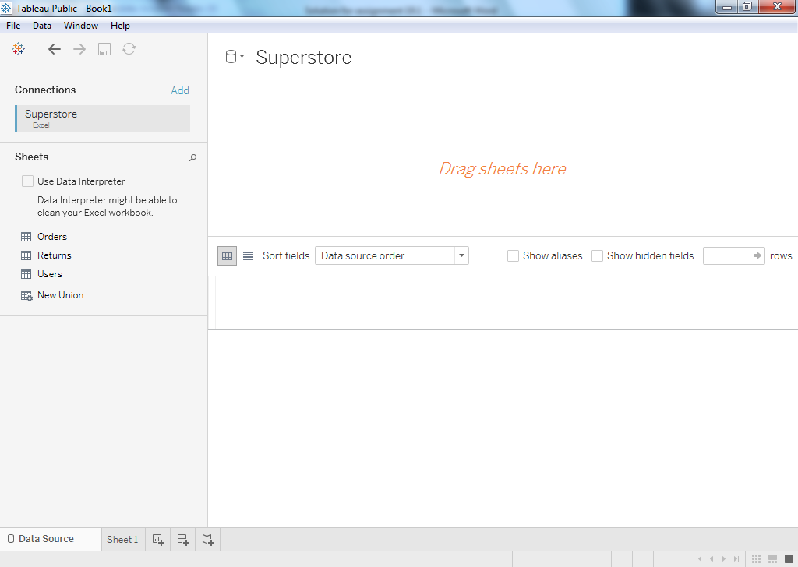

Then we will join orders, return and users.

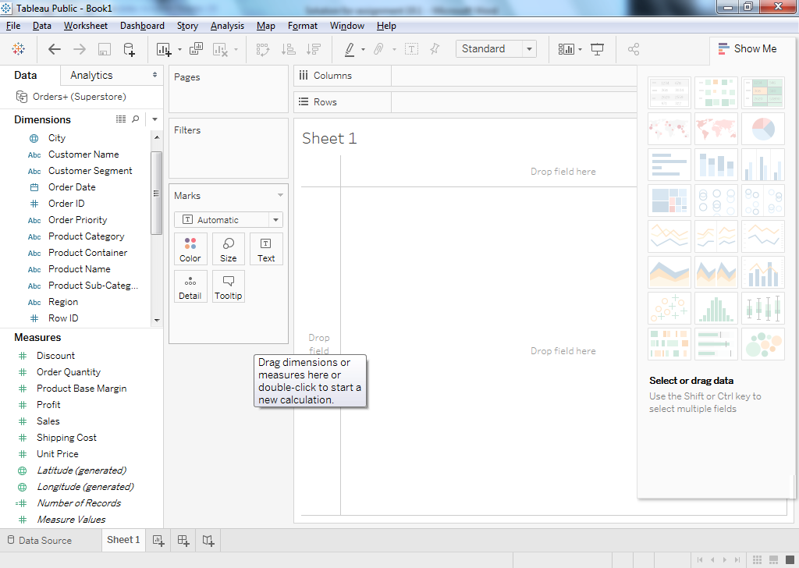

Then we will use sales along with different region and various customer segments to create a bar graph as shown in below screen shot.

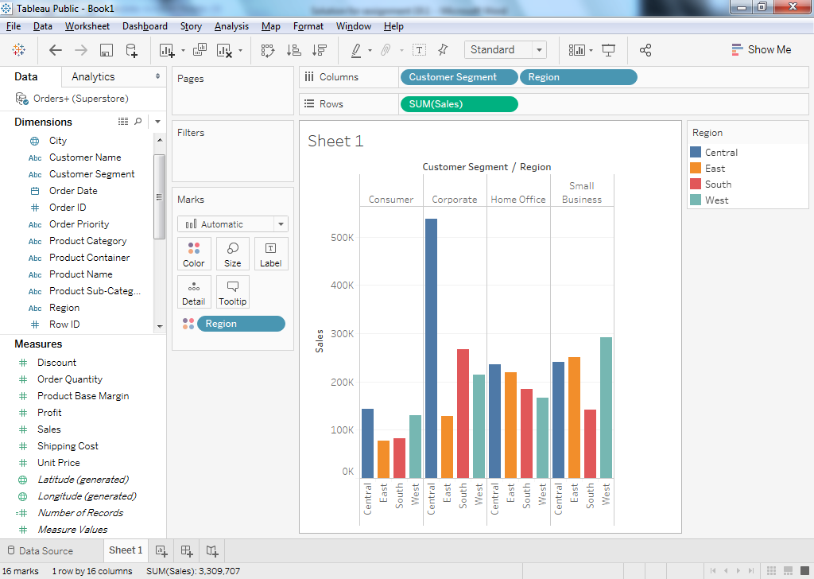

We can also create horizontal bar graph to show the above result but for a better visualization we will prefer side by side bar graph.

Results for horizontal bar graph.

